OUTPUT FOR 5----WEbAPI JWT TOKEN

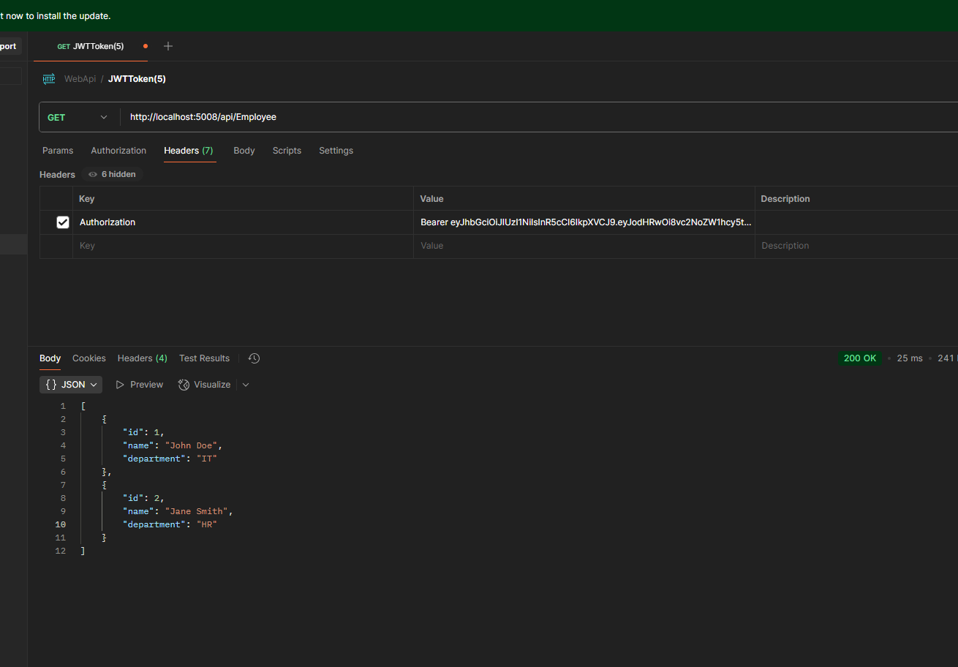

OUTPUT FOR 4----- WEBAPI CrudOperation(showing put opration in swagger and Postman)

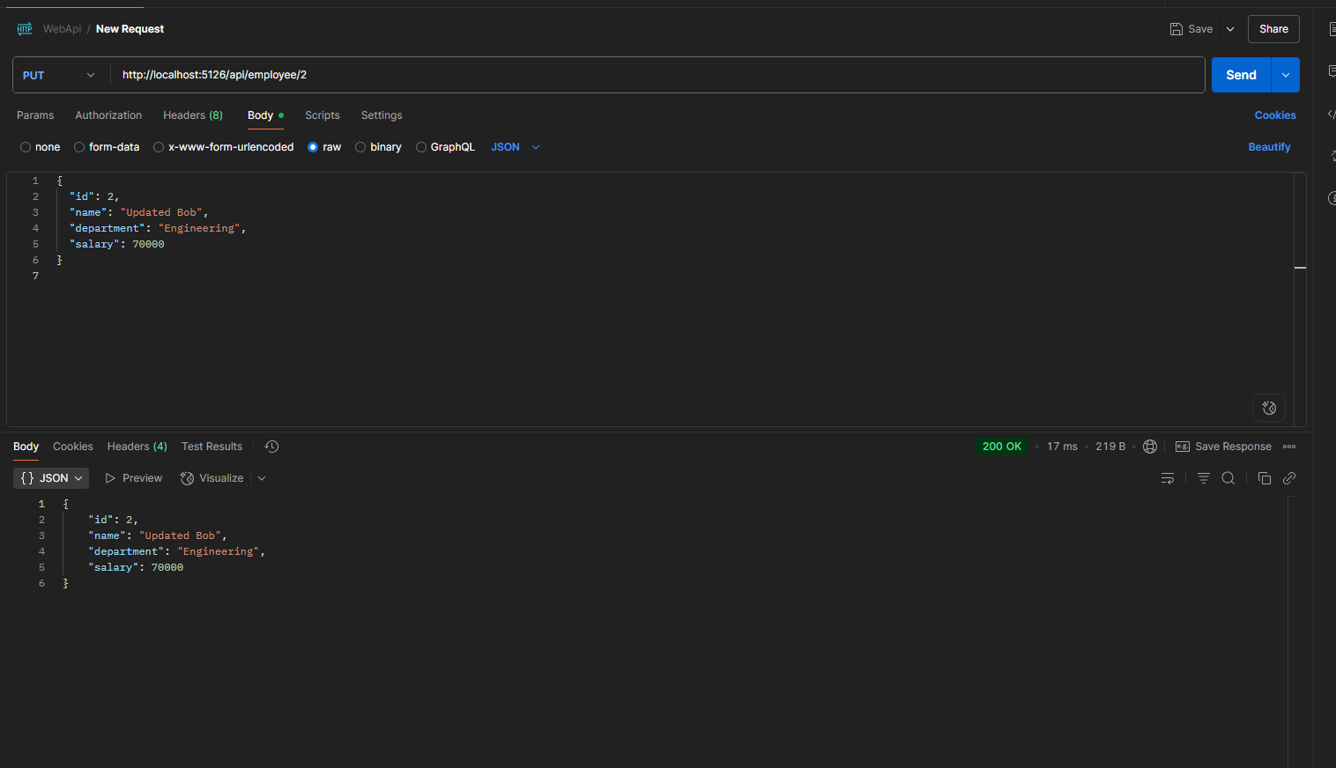

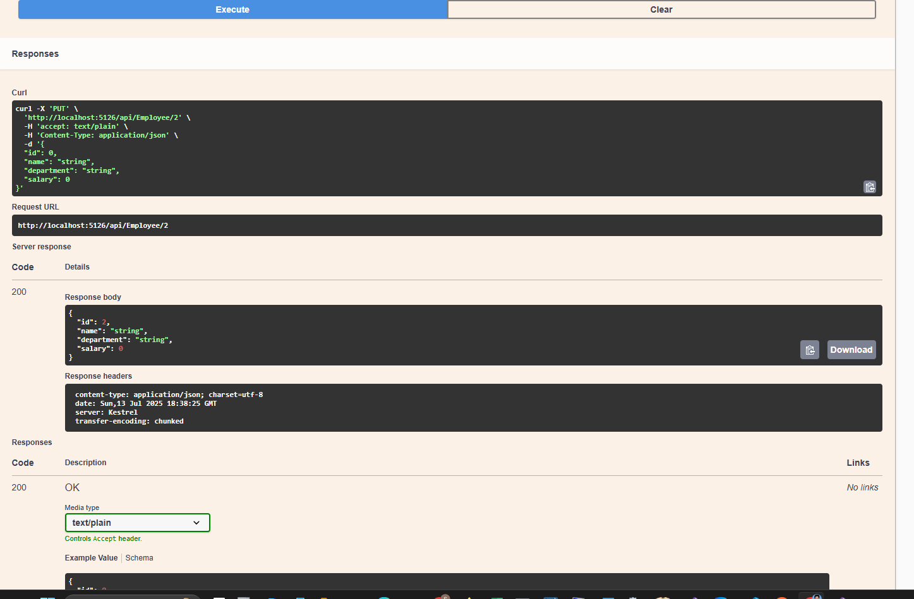

OUTPUT FOR 1 ---- WEBapi USING .NET core

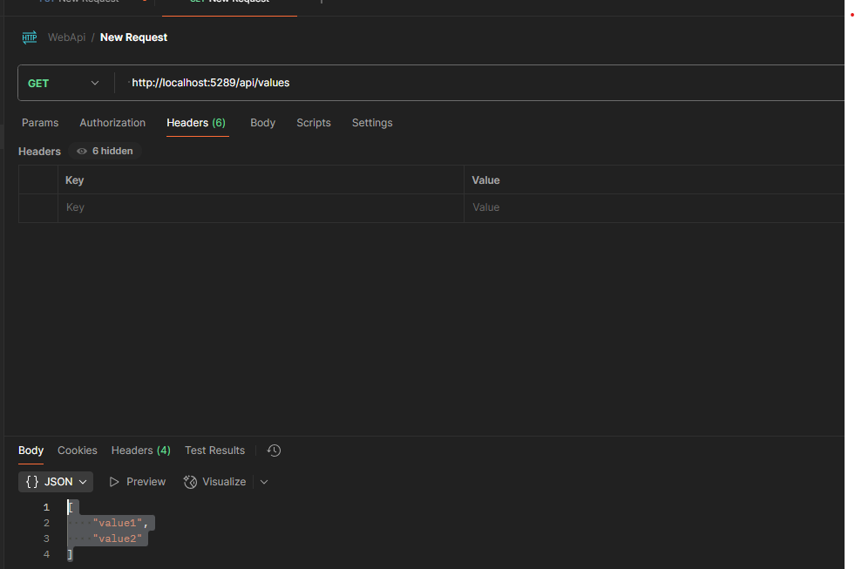

Output 2-----webApi .NET with Swagger

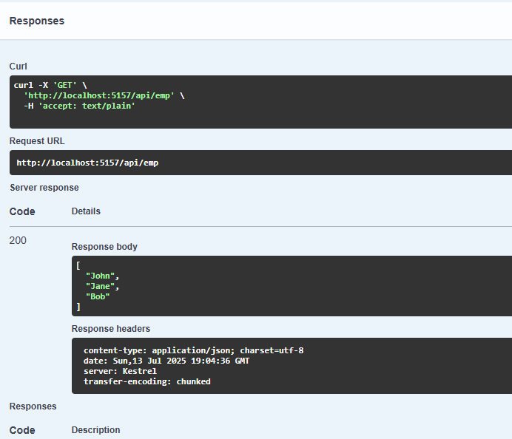

**Output 1----WEbapi Authorization**

